Activity3_1
Maria Sandate
2025-01-21

DANA4810: Jan 21
Real estate investors, homebuyers, and homeowners often use the appraised (or market) value of a property as a basis for predicting sale price. Data on sale prices and total appraised values of 76 residential properties sold in 2008 in an upscale Tampa, Florida, neighborhood named Tampa Palms are saved in the TAMPALMS file.

(a) Propose a straight-line model to relate the appraised property value x to the sale price y for residential properties in this neighborhood.
load ("C:/Users/sanda/Documents/Langara College/DANA-4810-001/Chapter 3/TAMPALMS.Rdata")
y <- TAMPALMS$Sale_Price
x <- TAMPALMS$Market_Val
# Scatterplot or Scatter Diagram
# Note: For 2 variables, X-var goes first in plot()
plot(x, # X-variable
y, # Y-variable
main = "Scatterplot of Sale Price vs. Value of a Property",
ylab = "Sale price",
xlab = "Value of a property",
cex = 0.8, # size of the dot
pch = 20, # style of the dot, default is 1
col = "blue")
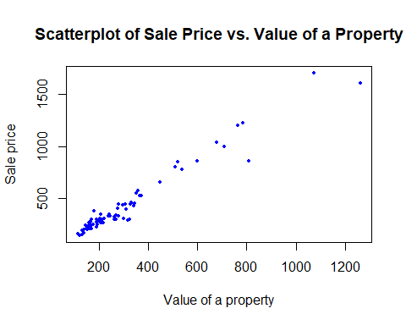
model=lm(y~x)
summary(model)
##
## Call:
## lm(formula = y ~ x)
##
## Residuals:
## Min 1Q Median 3Q Max
## -282.171 -24.829 1.807 29.791 188.792
##
## Coefficients:
## Estimate Std. Error t value Pr(>|t|)
## (Intercept) 1.35868 13.76817 0.099 0.922
## x 1.40827 0.03693 38.132 <2e-16 ***
## ---
## Signif. codes: 0 '***' 0.001 '**' 0.01 '*' 0.05 '.' 0.1 ' ' 1
##
## Residual standard error: 68.76 on 74 degrees of freedom
## Multiple R-squared: 0.9516, Adjusted R-squared: 0.9509
## F-statistic: 1454 on 1 and 74 DF, p-value: < 2.2e-16

(b) Interpret the y-intercept of the least squares line. Does it have a practical meaning for this application? Explain.
The y-intercept in the least squares line, represented by beta0, is the value of y when x = 0. In this case, it doesn’t have a realistic meaning because a property with no market value cannot have a sale price. Also, x = 0 is outside the range of observed x-values.

(c) Interpret the slope of the least squares line. Over what range of x is the interpretation meaningful?
The slope has a positive value, which means that x has a positive contribution on y. For every 1 unit increase in the market value of a property, the estimated sale price increases by 1.4. The interpretation of x is meaningful within the observed range, from xmin=113.1 to xmax=1262.3
summary(x)
## Min. 1st Qu. Median Mean 3rd Qu. Max.
## 113.1 170.4 229.2 305.6 330.8 1262.3

(d) Use the least squares model to estimate the mean sale price of a property appraised at $300,000.
beta0 = 1.35868
beta1 = 1.40827
x_hat = 300
y_hat=beta0+beta1*x_hat
y_hat
## [1] 423.8397

(e) Compute an estimate of σ.
y_length = length(y)
s=sqrt(sum(model$residuals^2)/(y_length-2))
s
## [1] 68.7566

